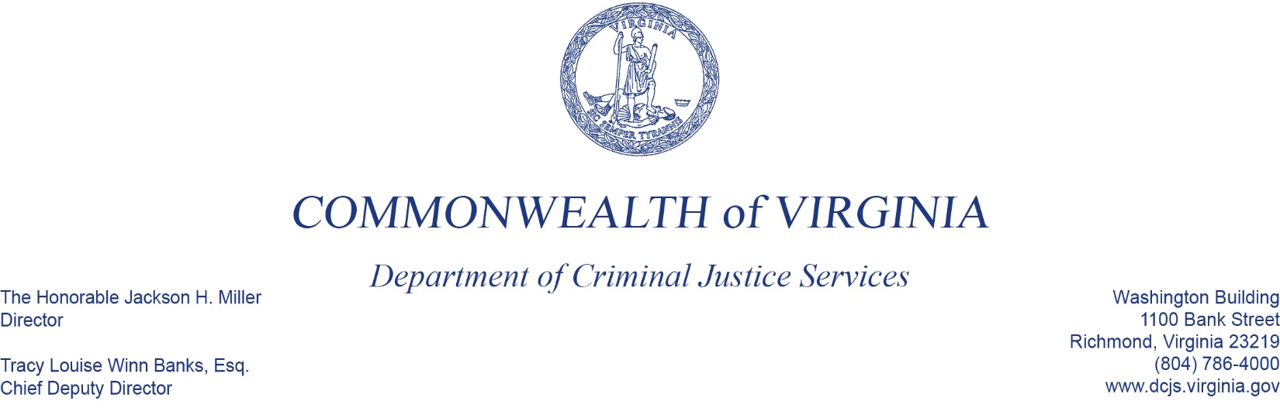
To: Criminal Justice Services Board Grants Committee
From: Jennifer MacArthur, Manager, Adult Justice Programs
Date: June 2, 2022
Re: FY23 Residential Substance Abuse Treatment (RSAT)

DCJS receives federal funding through the Residential Substance Abuse Treatment (RSAT) for Prisoners Grant Program. These funds will provide evidence-based residential traditional treatment or Medication-Assisted Treatment (MAT) services in local and regional jails. MAT is the use of medications, coupled with counseling and behavioral therapies, to primarily treat addictions to opiates.
New, competitive applicants for FY23 were required to demonstrate strong collaboration between a local or regional jail and a community service provider to increase the effectiveness of aftercare services. Priority was given to small/medium, rural jails; however, DCJS only received three applications. The City of Hampton Sheriff’s Office, Franklin County Sheriff’s Office (MAT) and George Mason University Partners will utilize the funding to implement MAT collaboration programs. Hampton Sheriff’s Office and Franklin County Sheriff’s Office were awarded RSAT Planning Grants for FY22. Hampton Sheriff’s Office will complete its program planning and move into implementation during FY23. These applications were reviewed by two internal reviewers and one external reviewer.
An additional four facilities applied for continuation funding. The Western Virginia Regional Jail requested continuation funds to enhance their MAT program. Norfolk Sheriff’s Office, Newport News Sheriff’s Office, and Henrico Sheriff’s Office have requested continuations of their implementation funding for MAT programs at level funding from FY22. These applications were reviewed by two internal reviewers.
RSAT funds do require a 25% local match. The request before you is for $670,146 in federal RSAT funds and $223,382 in required match, for a total of $893,528 for the seven applicants.

